**3D-Print Club Web App GUI Documentation**

(Title Page not final, please don’t include this in the grading for this draft)



**Forward**

This document was written with three purposes in mind:

1. To provide instructions on how to use the web app for it’s intended purpose.
2. To provide basic updating instructions to help 3D Print Club admins make small updates to the web app.
3. To provide admins with the resources to make big changes to the web app.

The bulk of this document will be a step by step walkthrough of the website with pictures. This document will cover creating accounts, logging in, viewing the printer statuses, creating a print request, viewing printer request statues, contacting the club admins, and viewing old requests.

For the admin side of the website, this document will demonstrate how to manage admin accounts and superusers, view current print requests, approve or deny print requests, message individual users, and schedule print jobs.

The end of the document will explain the code that goes into creating the GUI elements, and how changes to the website’s appearance can be made. There will also be additional resources linked at the end for more help with building web applications in ASP.Net Core and Razer Pages.

**How to Register or Login**

In order to make a printer request, first login, or create an account by clicking on the button that you need to use.

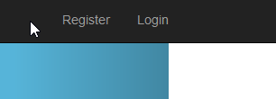

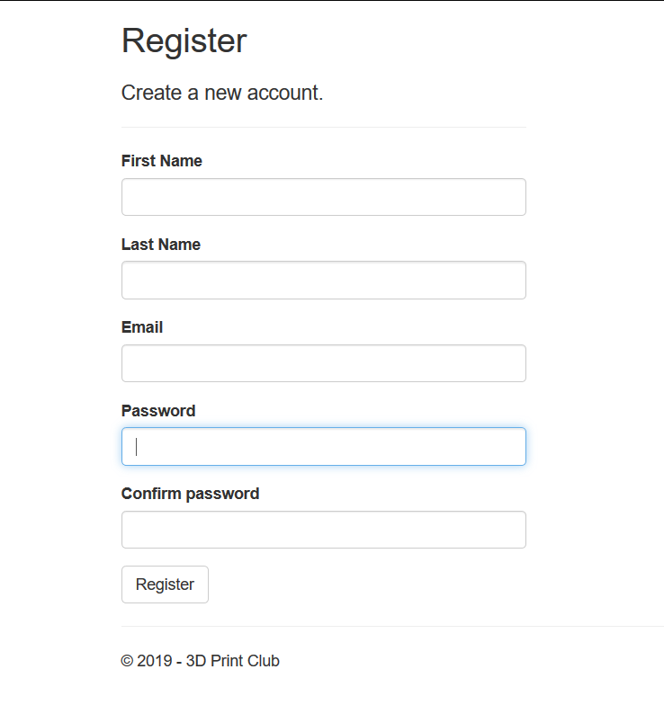When registering a new account, the following fields must be filled in:

* First Name
* Last Name
* Email
* Password

The email does not need to be an OIT email address, but using an OIT email is recommended.

The password must be at least six letters and requires a capital letter, a number, and one non alphanumeric character.

**How to recover an account**

A lost account can be recovered with the email that the account was registered with by clicking the log in button in the top right hand corner of the page. Then click the blue text under the log in button labeled as “Forgot your password”.

After entering the account email, the server will reply to that email with a message that will allow the password for that account to be reset.

**How admin accounts are set up**

In order to make an admin account, follow through the process of creating a normal account. Then contact the admin of the club. The website is set up in a way that designates one account as a super user. That user then can add, edit, or remove regular users. The super admin account can also add admin privileges to regular accounts by clicking on the tab labeled “User Management”. This tab will only appear in the tab bar for the user who has super user access.

In order to set up admin privileges the super admin must go to the user management page. Once inside the user management page, click “Edit” on the user that needs to be changed.

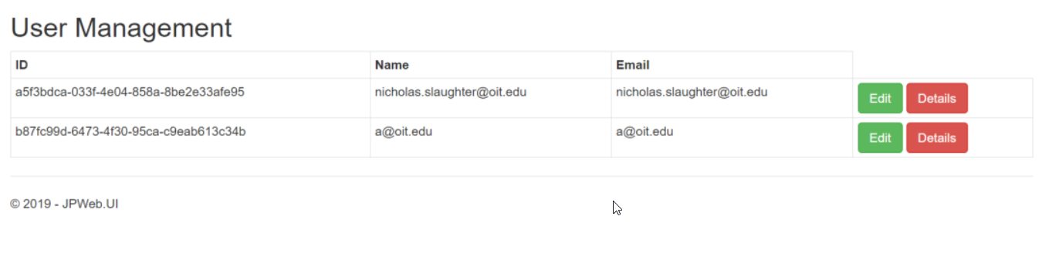

In the new page that comes up, check the box labeled “Administrator” under the Permissions label.

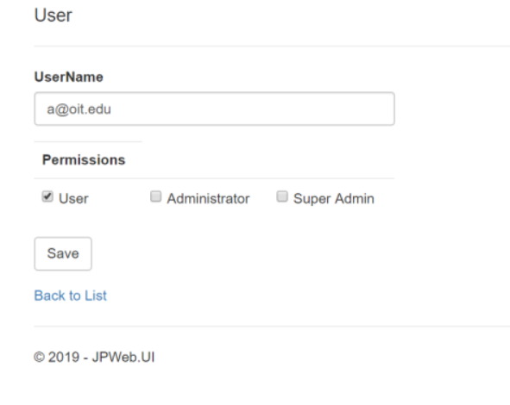

Another super admin may also be added by this through this same process by checking the “Super Admin” label.

**How to Submit a Printer Request**

To create a new printer request, navigate to the “**Make A Request**” button in the top of the page layout banner. This page will display all current and past print requests that the user has submitted.

In order to submit a new one, click the “**Create New**” link in the top right corner under the heading “Printer Requests”

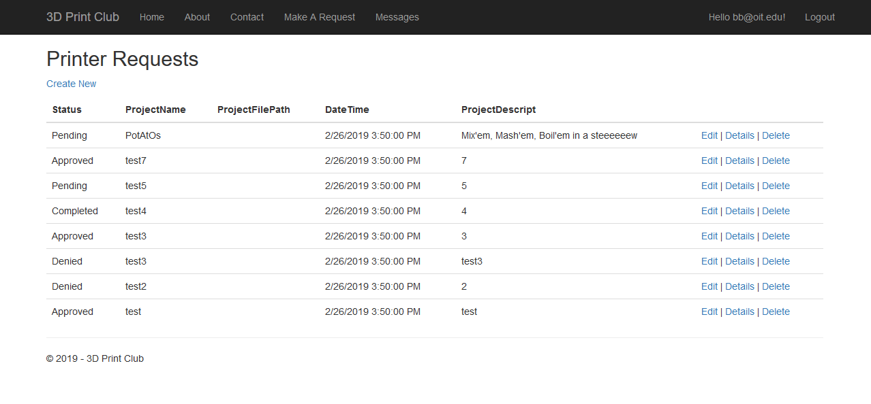

This brings up the form for a new request, in which there are two fields that require more than standard text.

For **ProjectFilePath** simply copy and paste the location of the project file from the file explorer.

The **Date Time** field can be easily filled in by clicking the arrows in the right side of the box, which opens a calander that will auto fill in the form based on the date clicked. The time stills needs to be typed in afterwards.

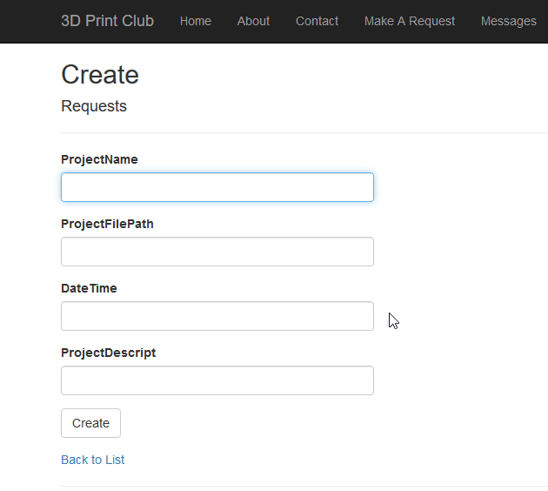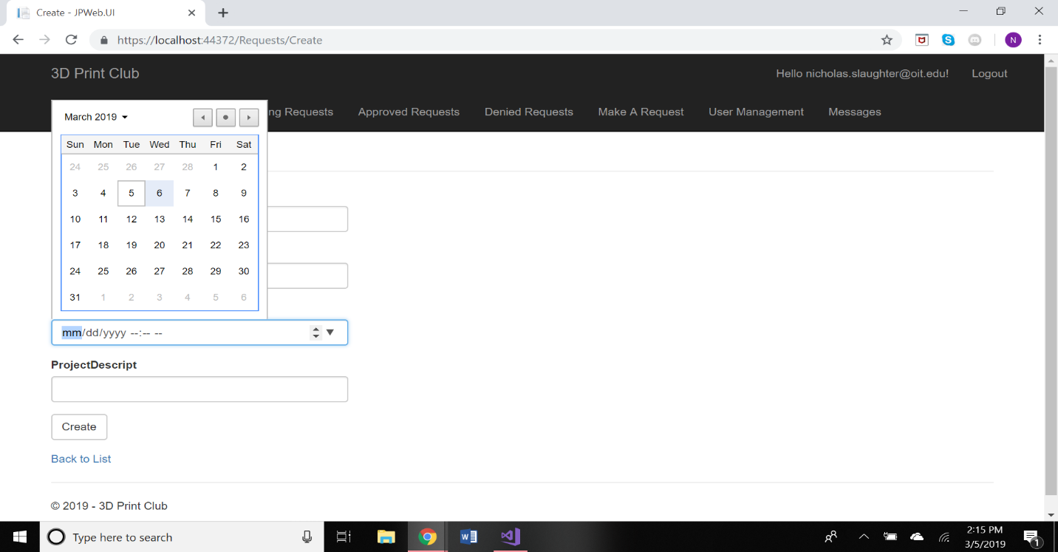

**Managin Requests (Admin Side)**

When logged in as an admin or super admin (picture below is from a super admin), there will be an extra 3 buttons in the paye layout banner. These are “Pending Requests”, “Approved Requests”, and “Denied Requests”. Requests initially are placed in the “Pending Requests” page when first submittted.

Each page functions the same, and gives the admin three ways to interact with each request.

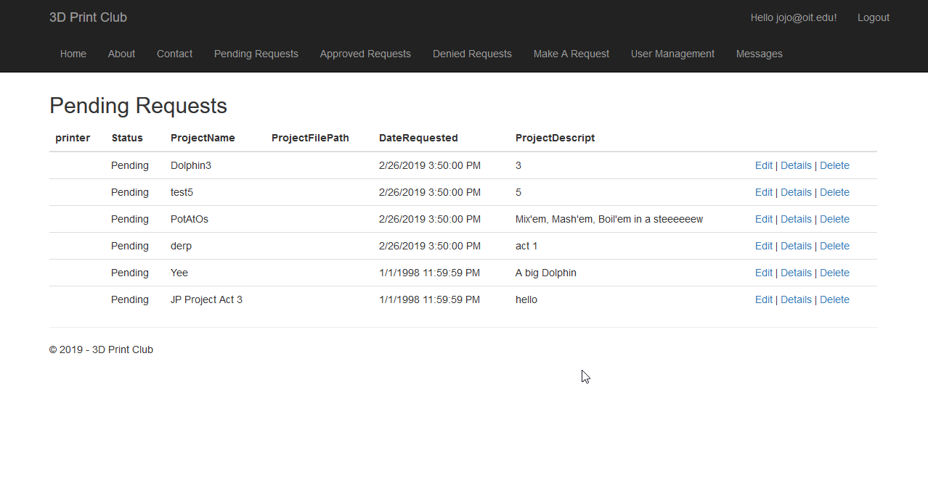

The “Edit” page allows admins to change the status of a printer to either Pending, Approved, or Denied. The request will get moved to the page the best fits it’s assigned status after being editted.

The “Edit” page also is how requests are assigned to printers.

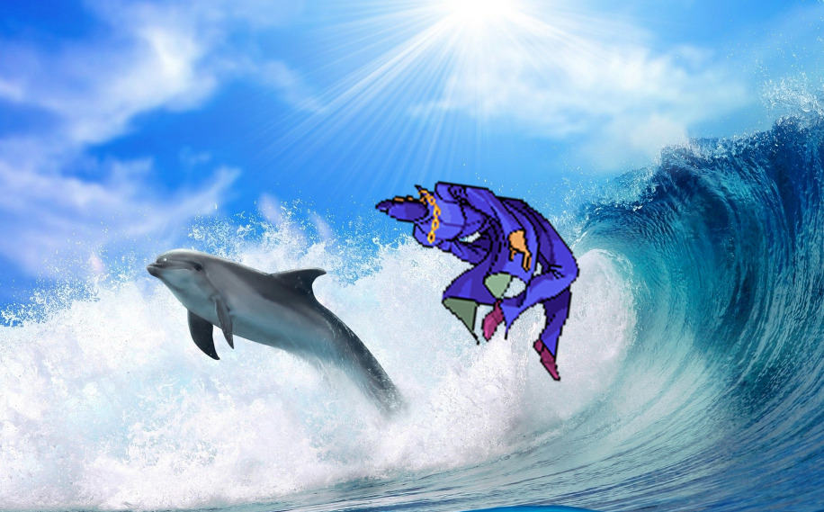

**How the Message Page Works**

This app is designed for users to message the admins of the 3D Print Club, **by default** the **message page will return** **empty** for new users.

**A new chatroom will be opened** once a **project has been submitted**. Once a single project has been submitted, the chat channel will always be open to message the admins of the club. Messages are private, no other users have access to them, however all admins can access every chatroom.

**How the Message Page Works on the Admin Side**

When clicking on the “Messages” button, the admins are taken to a different page. This page displays all of the chatrooms, known as Message Hubs. Each message hub contains one singular user.

The page is sorted with by most recent activity, placing the most recent conversations at the top.

The hubTitle is automatically set to be the name of the user’s most recent print submission.

To enter a user’s message hub, click the blue text “Message” on the far right of each entry in the table.

